Availability in a serial connection system = Availability of Unit 1 \* Availability of Unit 2 \* Availability of Unit 3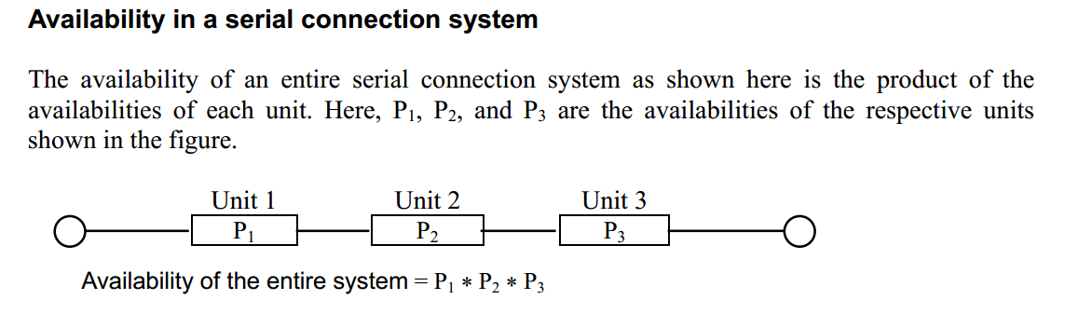

Availability in a parallel connection system = 1 – (1 - Availability of Unit 1) (1 - Availability of Unit 2) (1 - Availability of Unit 3)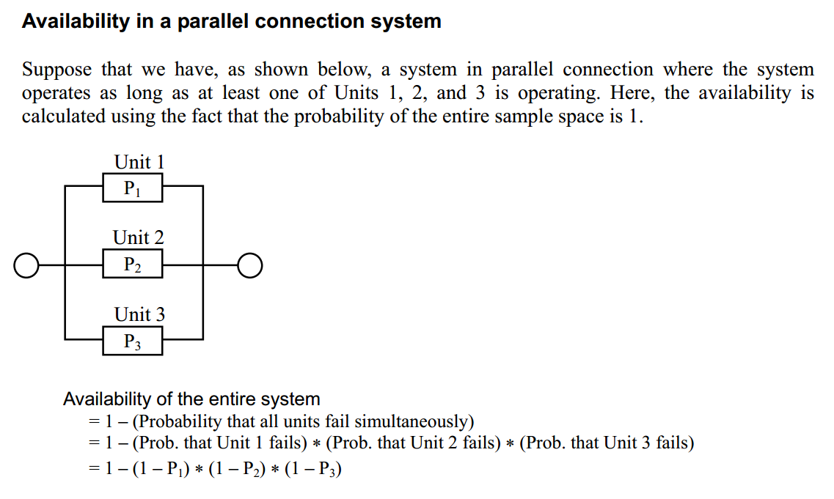

If failure rate is 0.1 then availability is 0.9

